AQA GCSE Dance - The Course

In GCSE Dance you will study both practically and theoretically whilst gaining knowledge of the history of dance, the work of established and upcoming choreographers, how to choreograph a piece and how to create an exciting performance for an audience. You will study a range of dance styles including Contemporary, Urban, Inclusive Dance, Dance for Camera/Site-Sensitive, as well as dance influence by other cultures.

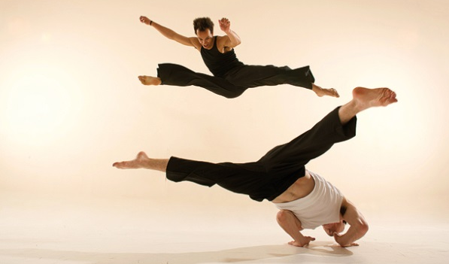
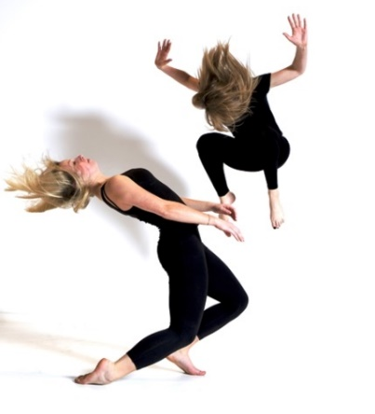
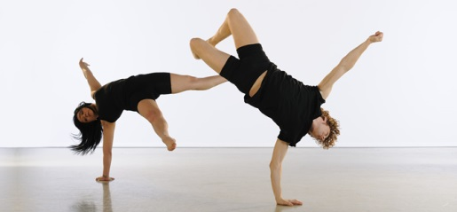
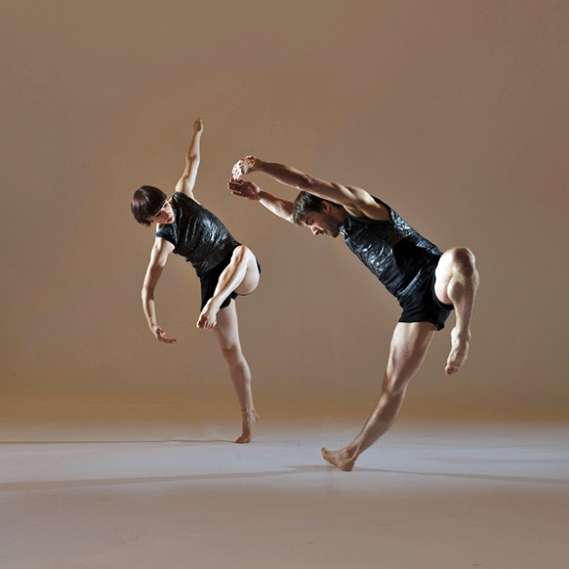
COMPONENENT 1 – PERFORMANCE 30% OF GCSE / 40 MARKS
YOU WILL PERFORM 2 SET PHRASES, EACH APPROXIMATELY 30 SECONDS LONG IN A CONTEMPORARY DANCE STYLE.
YOU WILL PERFORM A DUET/TRIO BETWEEN 3 ½ TO 5 MINUTES WHICH MOST SHOW A CLEAR CHOREOGRAPHIC INTENION AND INCLUDE ACTIONS GIVEN BY AQA.
YOU WILL BE MARKED ON YOUR TECHINCAL SKILLS (RADS), PHYSICAL SKILLS, EXPRESSIVE SKILLS, MENTAL SKILLS AND SAFE WORKING PRACTICE

COMPONENT 1 – CHOREOGRAPHY 30% OF GCSE / 40 MARKS
YOU WILL CREATE A SOLO OR GROUP DANCE BASED ON A STIMULUS/QUESTION.
E.G. IMAGE, PROP OR MUSIC.
YOU WILL BE MARKED ON YOUR ORGINALITY, RADS CONTENT, CHOREOGRPAHIC DEVICES AND STRUCTURE.

COMPONENT 2 – THE WRITTEN PAPER 40% OF GCSE / 80 MAKRS
SECTION A – KNOWLEDGE AND UNDERSTANDING OF CHOREOGRAPHIC PROCESSES AND PERFORMANCE SKILLS.
SECTION B – CRITICAL APPRECIATION OF OWN WORK.
SECTION C – CRITICAL APPRECIATION OF 6 PROFESSIONAL WORKS.

A Linha Curva | Within Her Eyes | Infra | Emancipation of Expressionism | Shadows | Artificial Things
Itzik Galili | James Cousins | Wayne McGregor | Kenrick H2O Sandy | Christopher Bruce | Lucy Bennett
Rambert Dance Company | James Cousins Company | The Royal Ballet | Boy Blue Entertainment | Phoenix Dance Theatre | Stopgap Dance Company
Contemporary, Brazilian Dance | Site-Sensitive, Contemporary, Contact Work | Contemporary Ballet | Urban | Contemporary | Inclusive Dance and Contemporary Dance
Carnival, Fun, Competition, Brazilian Culture | Love, Loss, Dependency, Loyalty, Memory | ‘Below’, beneath the surface of the city, Relationships | Individualism, Expressionism, Order and Chaos | Politics, Life, Deprivation, Family | Snow Globe, Peace, Resolution, Goran Djurovic Paintings

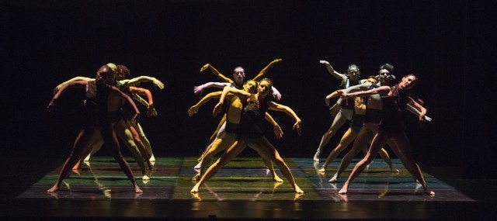
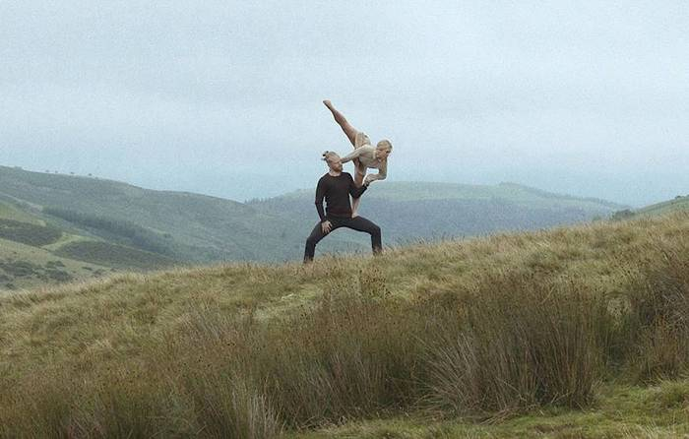

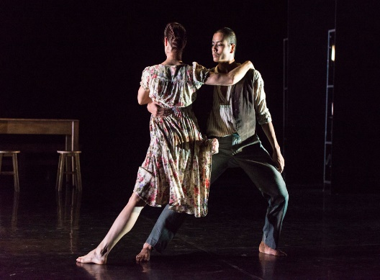
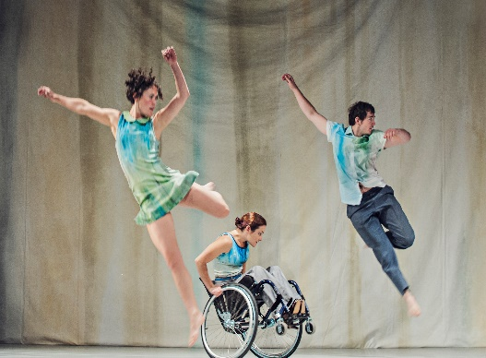
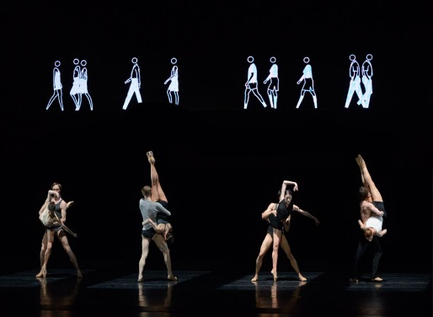
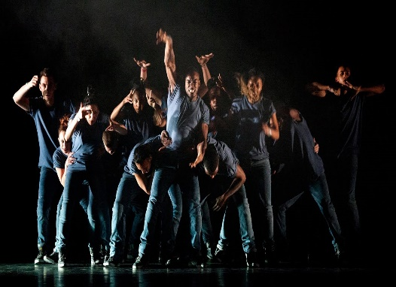

AQA GCSE Dance – Assessment Criteria

Performance
Demonstrations of physical skills and attributes safely to reproduce set phrases/reflect choreographic intent | Demonstration of technical skills (RADS) accurately and safely to reproduce set phrases/reflect choreographic intent | Demonstration of expressive skills to reproduce set phrases/reflect choreographic intent | Demonstration of mental skills and attributes during performance (commitment, confidence, movement memory)
In the Set Phrase each element is marked out of 4 and in the Duo/Trio each element is marked out of 8.
Scale: Exceptional, Highly Developed, Sound, Limited, Nothing Worthy of Credit.
Choreography
Selection and use of appropriate action and dynamic content to realise choreographic intention | Selection and use of appropriate spatial and relationship content to realise chorographic intention | Selection and use of appropriate structuring devices and form to realise choreographic intention | Selection and use of appropriate choreographic devices to realise choreographic intent | Selection and use of appropriate aural setting and performance environment to realise choreographic intent
Each element is marked out of 8.
Scale: Exceptional/Sophisticated, Highly Creative, Sound/Moderately Creative, Limited, Nothing Worthy of Credit.

